Abramova et al.(2020)

Abnormal Bid-Ask Spread is the natural logarithm of [total daily bid-ask

spread over the quarter, divided by the total daily bid-ask spread over the prior quarter]

We use the DTAQ database to compute the average daily percent of quoted bid-ask spreads and depths. Daily percent spread is the daily average of each quote’s spread, calculated as the difference between an offer price and a bid price, divided by the midpoint of the offer

and bid price.

Control Variables

|  |
| --- |
|  |
|  |

Guo et al.(2020)

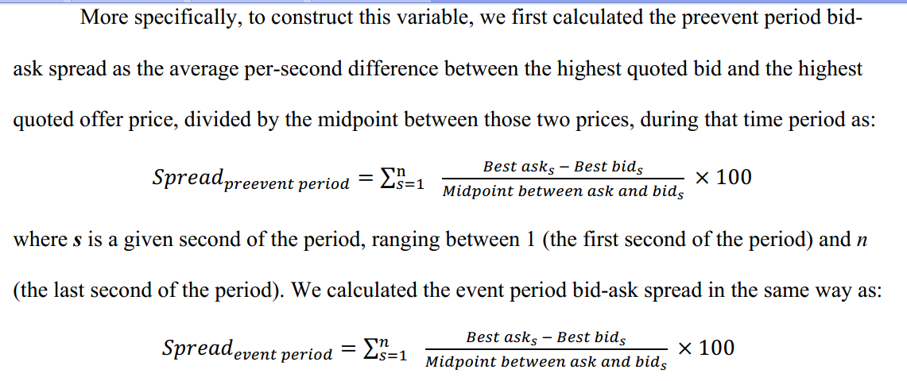

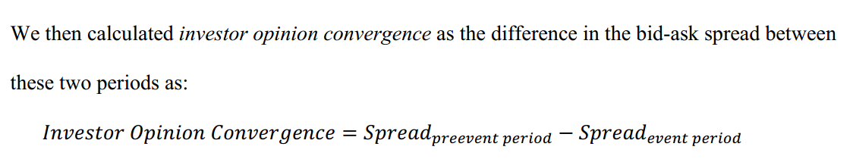

Control:

|  |
| --- |
|  |
|  |

Lee and Watts (2021)

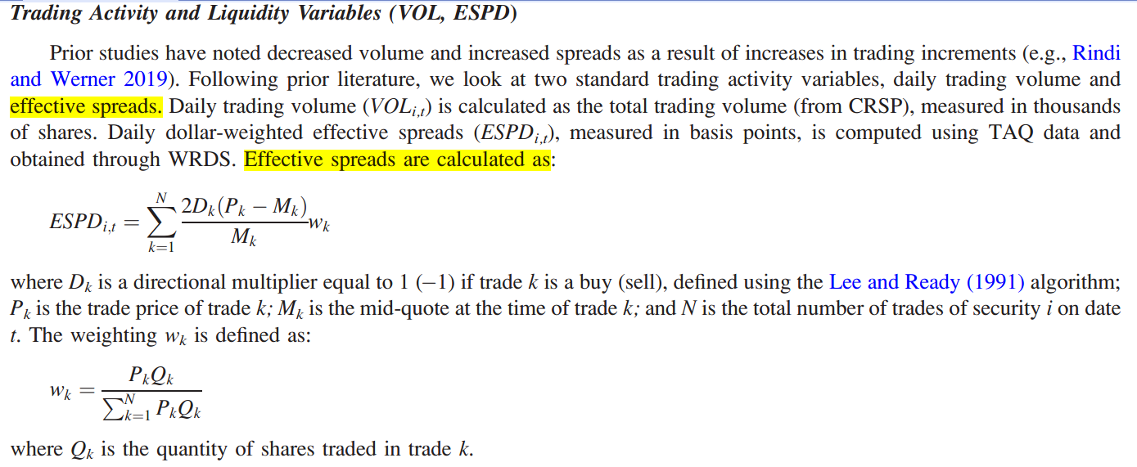

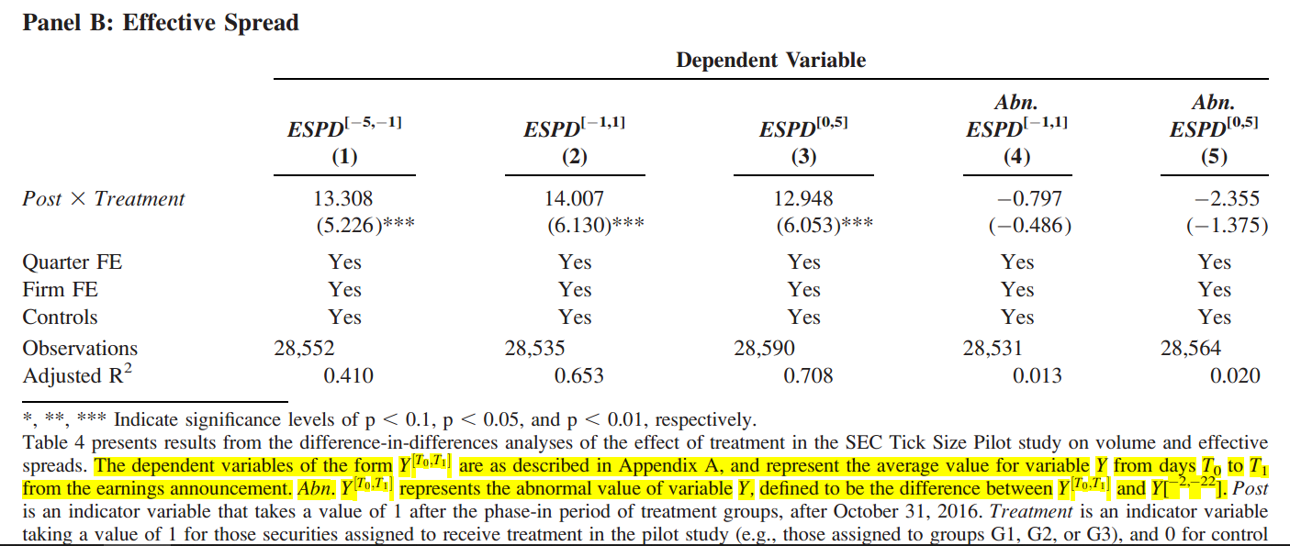



Control Variable

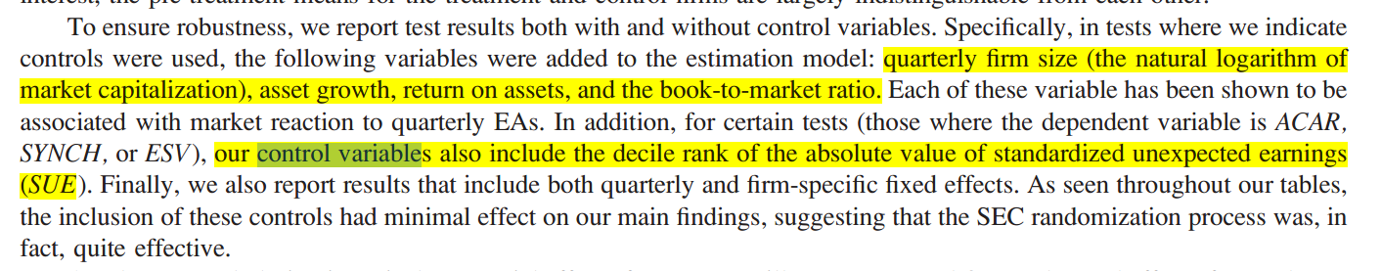

Schoenfeld et al.(2017)

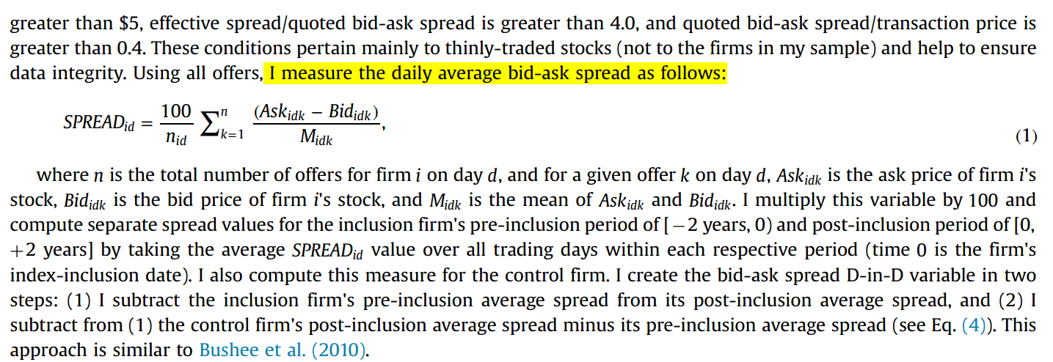

Control

|  |
| --- |
|  |
|  |

Nagar et al.(2019)

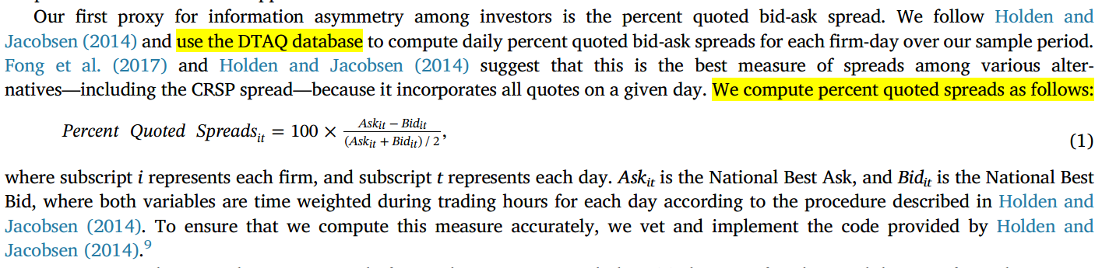

Control

|  |
| --- |
|  |
|  |